

**RED ART AN ART GALLERY MANAGMENT SYSTEM**

by

AKANSHA SINGH 1847205

J LEO CLITON 1847228

JAYAS P JACOB ­­­­­­­1847231

Under the guidance of

Prof. Smitha Vinod

DBMS project report submitted in partial fulfillment of the requirements for the award of degree of

Master of Computer Applications of

CHRIST (Deemed to be University)

October - 2019



CERTIFICATE

*This is to certify that the report titled RED ART AN ARGALLERY MANAGMENT SYSTEM**is a bona fide record of work done by* ***Akansha singh (1847205), J Leo Clinton (1847228) and Jayas P Jacob (1847231)*** *of CHRIST (Deemed to be University), Bangalore, in partial fulfillment of the requirements of III Semester MCA during the year 2019.*

**Head of the Department Project Guide**

Valued-by:

|  |  |  |  |
| --- | --- | --- | --- |
|  |  | Name | :J Leo Clinton |
| 1. |  | Register Number | :1847228 |
|  |  | Examination Centre | : CHRIST  (Deemed to be  University) |
| 2. |  | Date of Exam | : |

**CONTENTS**

1.INTRODUCTION

1.1 OVERVIEW OF THE SYSTEM

1.2 PROJECT PLAN

2.REQUIREMENT ANALYSIS

2.1 PROJECT STUDY

2.2 PROPOSED SYSTEM

2.3 LITERATURE REVIEW

2.4 TOOL SURVEY

3.SYSTEM REQUIREMENTS

3.1 SYSTEM MODEL

3.1.1MODULES DESCRIPTION

3.2 FUNCTIONAL REQUIREMENTS

3.3 HARDWARE REQUIREMENTS

3.4 SOFTWARE REQUIREMENTS

4.DESIGN SPECIFICATION

4.1 ARCHITECTURE DESIGN

4.2 DATABASE DESIGN

4.2.1 DATA FLOW DIAGRAM

4.2.2 ENTITY RELATIONSHIP DIAGRAM:

4.2.3 DATA DICTIONARY

5.IMPLEMENTATION

5.1 SOURCE CODE

5.2 SCREENSHOTS

6. TESTING

6.1 TEST PLAN

7.CONCLUSION

**1.INTRODUCTION**

**1.1 OVERVIEW OF THE SYSTEM**

Online Art Gallery is an online application, which is used to display, sell art and arrange schedule for exhibitions works of different artist .Artist can register online for being a member in the art gallery and each artist can upload the digital copy of their art work under the respective categories. They can host their art work exhibitions.

Customer can also register online and they can browse art works that are arranged in different categories scientifically. . Their displays a login page for administrator, artists and customers. Artists can login through their account and include details about new paintings made by them. Administrator can include details about new art gallery, upcoming exhibition details and the details about the artists who is hosting the exhibitions.

Each user has the right to purchase an art work using the integrated payment gateway and participate in exhibition. Deposit the amount using payment gateway and after each valid payment the art work will be shipped within 15 days. This project has been developed using the AJAX,BOOTSTRAP,JAVASCRIPT front end and MYSQL as the back end.

**1.2 PROJECT PLAN**

|  |  |
| --- | --- |
| TITLE: RED ART AN ART GALLERY MANAGMENT SYSTEM | |
| DEPARTMENT: Computer Science | |
| DATE | PHASE |
| 5thJune - 20th June | Finalize the concept of the project |
| 20th June - 5th July | Analysis phase |
| 5st July - 20th July | Design phase |
| 20 th July- 5thAugust | Coding |
| 5thAugust-20thAugust | Coding |
| 20thAugust-5thSepetember | Testing |
| 5thSepetember - 20thSepetember | Final report submission |

Table 1.1 project plan

**2.REQUIREMENT ANALYSIS**

**2.1 PROJECT STUDY:**

**Existing System –**

The current systems are computerised but the system doesn’t have exhibition option of an art gallery hence restricting the look and feel of the property while viewing from the website. Also, top artist and customers are not listed in the websites which makes the existing system not customer oriented.

**Limitations of Existing System –**

* Street map and exhibition location view is not available.

**2.2 PROPOSED SYSTEM**

ONLINE ART GALLERY is application software and it is very helpful for the art lovers and others who want to know the addresses where this kind of arts will we sold. This application helps the end-users to search their arts and paintings and they can place order for the selected pieces. The enduser can also get the information about the art exhibition and the respective address, so, that they can visit to those exhibitions. Art Gallery brings you an opportunity to view online art exhibitions at our Online Art Gallery we bring you details of all art exhibitions held in the past and the forthcoming show.

The Online Art Gallery is updated daily, so the user can view and buy the latest collection of contemporary art online from any where in the world. You can view and buy the latest Indian contemporary art collection available at their exhibitions and also at their online gallery.

**Benefits of Proposed System :**

* Consists of street maps
* Well maintained database
* Report of the art pieces sold each time
* Customer oriented
* Convenient login for users

**2.3 LITERATURE REVIEW:**

* Art gallery Management System (AGMS) is an online software application that manages the overall operational activities and processes, starting from the management of the art, to the management of the artists, customer and financial transactions.

Few AGMS websites have been discussed below:

* MyIndian Art is an online art shopping site which offers online search, buying, home and so on for customers to have their own dream art designs. This website has many drawbacks such as no instance response notification and there are no separate enquiry area to ask about the art which is out of stock.
* There are many online art gallery management systems which provides good offers and are tied up with many artist all around the world. There is good income from this source as well. Yet there are many loop holes that the existing system consists.

**2.4 TOOL SURVEY**

* Node.js

Node.js is a server-side platform built on Google Chrome's JavaScript Engine (V8 Engine). Node.js was developed by Ryan Dahl in 2009 and its latest version is v0.10.36. The definition of Node.js as supplied by its [official documentation](https://nodejs.org/) is as follows .

Node.js is an open source, cross-platform runtime environment for developing server-side and networking applications. Node.js applications are written in JavaScript, and can be run within the Node.js runtime on OS X, Microsoft Windows, and Linux.Node.js also provides a rich library of various JavaScript modules which simplifies the development of web applications using Node.js to a great extent.

* MySQL

MySQL is an Oracle-backed open source relational database management system ([RDBMS](https://searchdatamanagement.techtarget.com/definition/RDBMS-relational-database-management-system)) based on Structured Query Language ([SQL](https://searchsqlserver.techtarget.com/definition/SQL)). MySQL runs on virtually all

platforms, including [Linux](https://searchdatacenter.techtarget.com/definition/Linux-operating-system), [UNIX](https://searchdatacenter.techtarget.com/definition/Unix) and [Windows](https://searchwindowsserver.techtarget.com/definition/Windows). Although it can be used in a wide range of applications, MySQL is most often associated with web applications and online publishing.

MySQL is an important component of an open source enterprise stack called [LAMP](https://whatis.techtarget.com/definition/LAMP-Linux-Apache-MySQL-PHP). LAMP is a web development platform that uses Linux as the operating system, [Apache](https://whatis.techtarget.com/definition/Apache) as the web server, MySQL as the relational database management system and [PHP](https://whatis.techtarget.com/definition/PHP-Hypertext-Preprocessor) as the object-oriented scripting language. (Sometimes [Perl](https://whatis.techtarget.com/definition/Perl) or [Python](https://whatis.techtarget.com/definition/Python) is used instead of PHP.)

* HTML

HTML stands for Hyper Text Markup Language and was intended to be used solely to provide document structure for a text based communication medium. Hypertext Markup Language commonly referred to as HTML is the standard markup language used to create web pages. It is written in the form of HTML elements consisting of tags enclosed in angle brackets (like <html>). HTML tags most commonly come in pairs like <h1> and </h1>, although some tags represent empty elements and so are unpaired, for example <img>. The first tag in a pair is the start tag, and the second tag is the end tag (they are also called opening tags and closing tags). Web browsers can read HTML files and compose them into visible or audible web pages. Browsers do not display the HTML tags and scripts, but use them to interpret the content of the page. HTML describes the structure of a website semantically along with cues for presentation, making it a markup language, rather than a programming language.HTML elements form the building blocks of all websites. HTML allows images and objects to be embedded and can be used to create interactive forms. It provides a means to create structured documents by denoting structural semantics for text such as headings, paragraphs, lists, links, quotes and other items.

* CSS:

Web browsers can also refer to Cascading Style Sheets (CSS) to define the look and layout of text and other material. Cascading Style Sheets (CSS) is a simple method for adding style (e.g. fonts, colours, and spacing) to Web documents. Style sheets describe how documents are presented on screens, in printed etc.; it gives a consistent look to the web pages. In fact, CSS has become the preferred web design method for today's website design creators. With one or two style sheets the colours, fonts, links, and other elements of the web pages can be kept the same throughout your site without having to hard code the same information on each and every page of the site. Using CSS saves time.

CSS makes it easy to improve the appearance of a website by allowing us to create a much more stylish website since CSS offers a wide array of expressive style capableness. With CSS, we will actually obtain more control over the website's visual aspect. One of the convenient features that CSS produces is the consistency it provides when we want to make changes to a website. When a change is made to the websites CSS Style Sheet, we will have the ability to automatically correct or change every page throughout the website--all at once. It is not required to have to go in to each individual web page to make a particular change as CSS will instantly do it. If the website is rather large, this one simple feature will save the user’s ample time.

* JAVASCRIPT:

JavaScript can function as both a procedural and an object oriented language. Objects are created programmatically in JavaScript, by attaching methods and properties to otherwise empty objects at run time, as opposed to the syntactic class definitions common in compiled languages like C++ and Java. Once an object has been constructed it can be used as a blueprint (or prototype) for creating similar objects. JavaScript's dynamic capabilities include runtime object construction, variable parameter lists, function variables, dynamic script creation (via eval introspection (via for ... in), and source code recovery (JavaScript programs candecompile function bodies back into their source text). JavaScript is also used in environments that are not Web-based, such as PDF documents, site-specific browsers, and desktop widgets. Newer and faster JavaScript virtual machines (VMs) and platforms built upon them have also increased the popularity of JavaScript for server- side Web applications. On the client side, JavaScript has been traditionally implemented as an interpreted language, but more recent browsers perform just-in-time compilation. It is also used in game development, the creation of desktop and mobile applications, and server-side network programming with run-time environments such as Node.js.

* AJAX
* AJAX is stands for Asynchronous JavaScript and XML.AJAX is a technique for creating fast and dynamic web pages.AJAX allows web pages to be updated asynchronously by exchanging small amounts of data with the server behind the scenes. This means that it is possible to update parts of a web page, without reloading the whole page.Classic web pages, (which do not use AJAX) must reload the entire page if the content should change.
* Examples of applications using AJAX: Google Maps, Gmail, Youtube, and Facebook tabs.s
* BOOTSTRAP

Bootstrap is the most popular CSS Framework for developing responsive and mobile-first websites.

Additionally, Bootstrap requires [**jQuery**](https://jquery.com/) to function. jQuery is an extremely popular and widely used JavaScript library, that both simplifies and adds cross browser compatibility to JavaScript.

Everything else you might happen across while studying the Bootstrap documentation - Grunt, Gulp, Sass, LESS, bower, npm, etc - is not necessary to get started with Bootstrap. These are task runners, preprocessors, installation aids, and package managers, so don't be discouraged if you don't know how to use any of them yet.

rameworks are very popular and have many benefits, so it's important to learn how to work with them.

Some of the ways that frameworks can help you:

* Prevent repetition between projects
* Utilize responsive design to allow your website to adapt to various screen sizes - mobile, desktop, and everything in between
* Add consistency to design and code between projects and between developers
* Quickly and easily prototype new designs
* Ensure cross-browser compatibility

**3.SYSTEM REQUIREMENTS**

**3.1 SYSTEM MODEL**

Fig 3.1 System Model

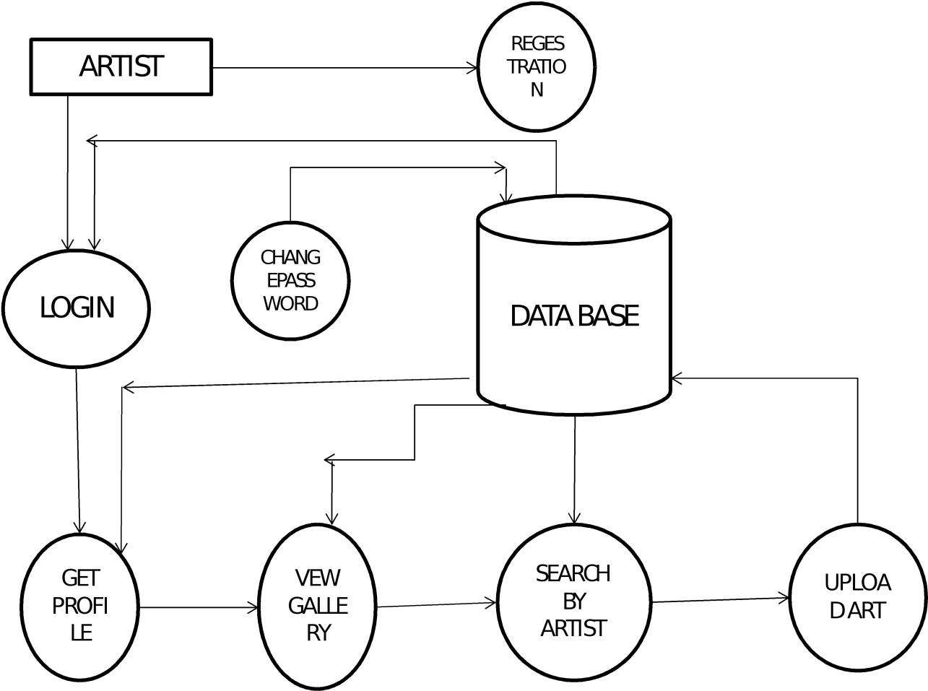

**3.1.1MODULES DESCRIPTION:**

The activities of store that the system will automate are:

* Login
* Entry of new art gallery
* Entry of new artist
* Entry of new Painting
* Details of upcoming exhibition
* Accessing contact details of gallery as well as artists and their paintings.
* Entry of Customer details, painting bought.
* **LOGIN:**

This module is designed for both customer , artist and the admin. Before loging the customer,artist both should register with their mail ID and create a password.

* **CUSTOMER:**

Includes people who are involved in purchase of the property.The user can view the arts available in and search for other arts according to the name or price. The user can order , pay and get their art will get delivered. After the art is delivered or before as well a customer can should rate the art he lately brought and enjoyed and reading blogs are also possible.

* **ARTIST**

Artists can login through their account and include details about new paintings made by them and can set exhibition schedule.

* **ADMIN**

Administrator can include details about new art ­­­­­­­gallery, upcoming exhibition details and the exhibition artists and can manage accounts.

* **PAYMENT**:

Includes payment details with otp generation.

**3.2 FUNCTIONAL REQUIREMENTS:**

**As a Customer:**

You can search the different arts available.

Make an enquiry.

Reading blogs related to arts.

Likes on the purchase.

**As an Admin:**

Add, Remove or Update user accounts and arts.

Have an overall incharge of the website

**3.3 HARDWARE REQUIREMENTS**

The proposed system does not have any explicit hardware requirements.

**Processor:** Intel core2 Duo or higher

**Ram :** 1 GB and above

**Storage :** 10 GB

**3.4 SOFTWARE REQUIREMENTS**

The below are the specified software requirements for the system to run successfully.

**Operating System**: Windows XP or Higher , mac os

**Front end:** HTML, AJAX,JAVA SCRIPT,BOOTSTRAP

**Back end:** MySQL,Nodejs

**Documentation :** Microsoft Word-2017

**4.DESIGN SPECIFICATION**

**4.1 ARCHITECTURE DESIGN:**

The proposed system uses Three-tier architecture. Three-tier architecture is a client–server software architecture pattern in which the users interface, functional process logic, computer data storage and data access are developed and maintained as independent modules, most often on separate platforms. Explanations for different tiers are given

below:

**1. Presentation tier**

This is the topmost level of the application. It communicates with other tiers by which it puts out the results to the browser/client tier and all other tiers in the network. In simple terms, it is a layer which users can access directly.

**2. Application tier (business logic, logic tier, or middle tier)**

The logical tier is pulled out from the presentation tier and, as its own layer; it controls an application’s functionality by performing detailed processing.

**3. Data tier**

The data tier includes the data persistence mechanisms (database servers, file shares, etc.) and the data access layer that encapsulates the persistence mechanisms and exposes the data.

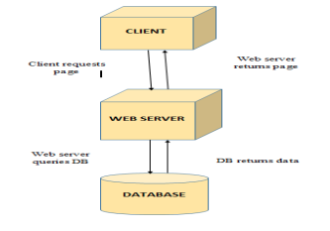

fig 4.1 three tier architecture

**4.2 DATABASE DESIGN**

**4.2.1 DATA FLOW DIAGRAM:**

**CONTEXT LEVEL:**

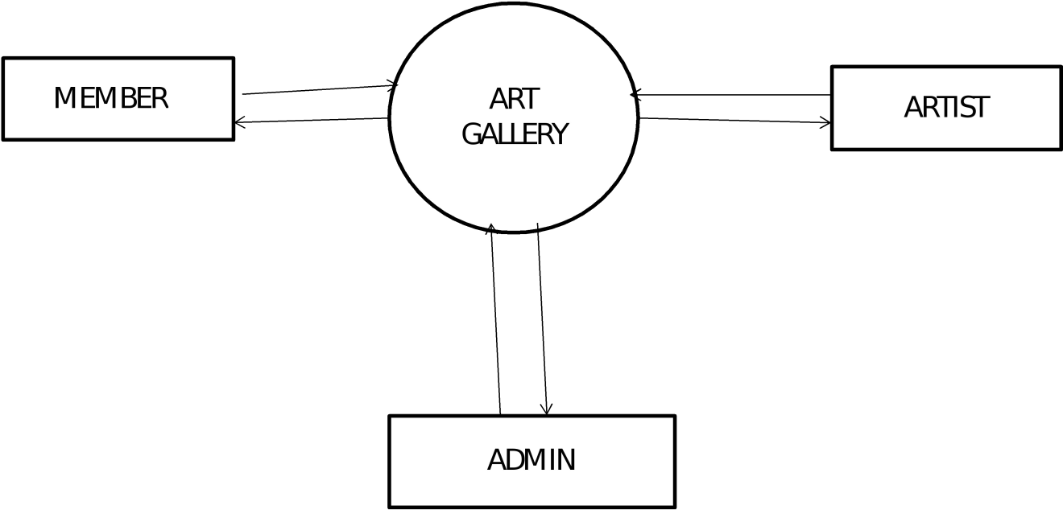

**Fig4.2 level 0 dfd**

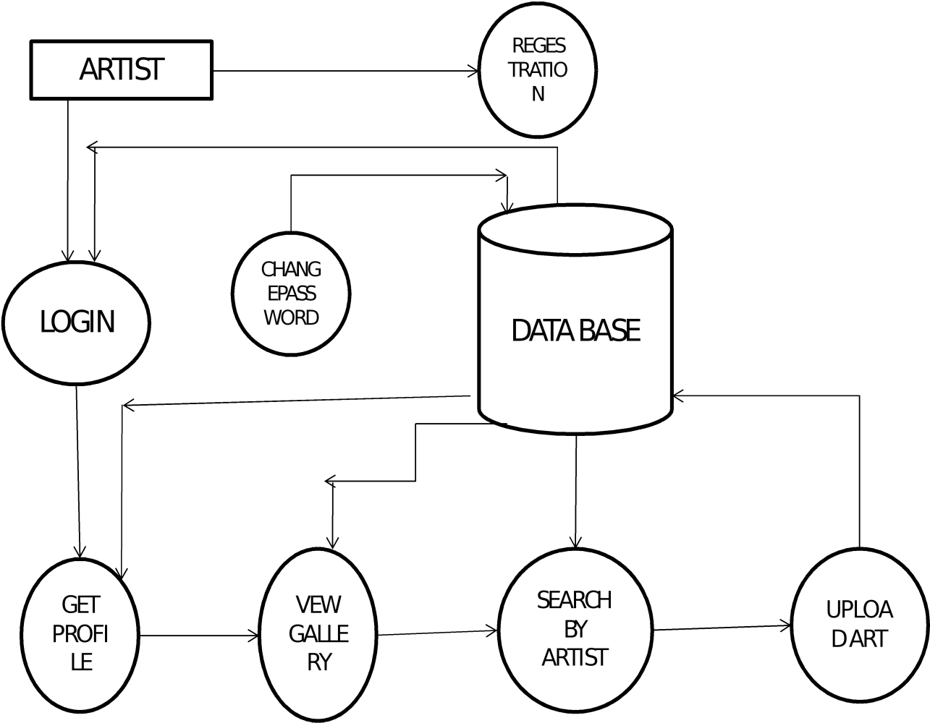

Here the user registers into system and views property details. The admin verifies and manages the entries into the system.

**Fig4.3 level 1 dfd**

**4.2.2 ENTITY RELATIONSHIP DIAGRAM:**

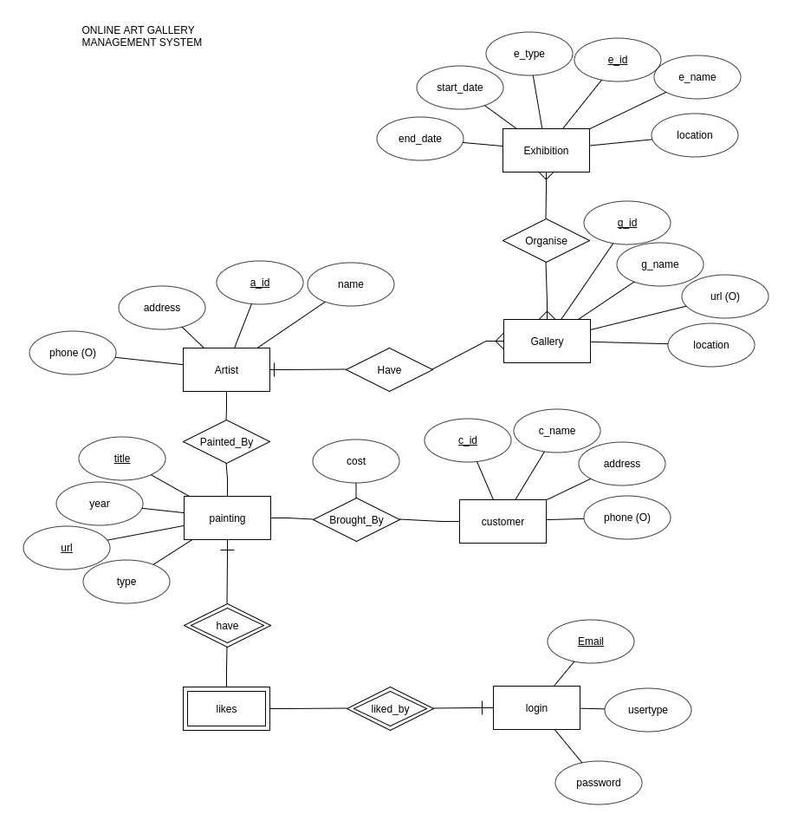

Fig 4.4 ER diagram

**4.2.3 DATA DICTIONARY**

Table 4.1 signlogin

|  |  |  |  |  |  |
| --- | --- | --- | --- | --- | --- |
| **FIELD NAME** | **DATATYPE** | **DATA FORMAT** | **FIELD SIZE** | **DEX** | **EXAMPLE** |
| Customer_id  (PK)(NN)(AI) | CHAR |  | 20 | Unique rating id | 2055 |
| Fname  (NN) | CHAR |  | 20 | First name of the customer | Mango |
| Lname  (NN) | CHAR |  | 20 | Last name of the customer | Kerala |
| Phone  (NN) | BIGINT | NNNNNNN | 11 | Phone number of the customer | 9003010180 |
| Email  (NN) | VARCHAR |  | 45 | Email id of the customer | [mango@gmail.com](mailto:mango@gmail.com) |
| Password  (NN) | VARCHAR |  | 45 | Password for the website | ********* |

Table 4.2 Contact

|  |  |  |  |  |  |
| --- | --- | --- | --- | --- | --- |
| **FIELD NAME** | **DATATYPE** | **DATA FORMAT** | **FIELD SIZE** | **DEX** | **EXAMPLE** |
| Contact_id  (PK)(NN)  (AI) | CHAR |  | 20 | Unique id for message | 1005 |
| Name  (NN) | CHAR |  | 20 | Name of message sender | Mango |
| Email  (NN) | VARCHAR |  | 20 | Email of message sender | [mango@gmail.com](mailto:mango@gmail.com) |
| Contact  (NN) | BIGINT | XXXXXXXXX | 11 | PH No of message sender | 9661768921 |
| Message  (NN) | VARCHAR |  | 200 | Message | Nice website |

**TABLES**

**CUSTOMER**

|  |  |  |  |  |
| --- | --- | --- | --- | --- |
| **C_ID** | **C_NAME** | **PHONE_NO** | **ADDRESS** | **ZIP_CODE** |

**ARTIST**

|  |  |  |  |
| --- | --- | --- | --- |
| **A_ID** | **A_NAME** | **ADDRESS** | **PHONE_NO.** |

**GALLERY**

Since artist name is only required for the gallery table artist ID (A_ID) is need to split in two.

|  |  |  |  |  |  |  |  |
| --- | --- | --- | --- | --- | --- | --- | --- |
| **G_ID** | **G_LIKES** | **G_DES** | **G_NAME** | **G_COST** | **G_IMAGES** | **A_ID** | **G_TYPE** |

**Artist_gallery**

|  |  |  |
| --- | --- | --- |
| **A_ID (PK)** | **G_ID (FK)** | **A_NAME** |

**EXHIBITION**

|  |  |  |  |  |
| --- | --- | --- | --- | --- |
| **E_ID** | **E_TYPE** | **E_DATE** | **E_NAME** | **LOCATION** |

**TRANSACTION**

T_MODE Which is transaction mode here, which has four types of transactions and it’s indirectly related to transaction. Hence transitive property is observed in such case we will split the transaction table into two.

|  |  |  |  |  |
| --- | --- | --- | --- | --- |
| **T_ID(PK)** | **T_DATE** | **C_ID** | **T_MODE** | **G_ID** |

**T_MODE**

|  |  |  |
| --- | --- | --- |
| **T_MODE_ID** | **T_ID** | **T_MODETYPE** |

**LOGIN**

|  |  |  |
| --- | --- | --- |
| **LOGIN_ID** | **PASS** | **EMAIL** |

**5.IMPLEMENTATION**

**5.1 SOURCE CODE**

**1.Home page**

{% load static %}

<!DOCTYPE html>

<html lang="en">

<head>

    <meta charset="UTF-8">

    <meta name="viewport" content="width=device-width, initial-scale=1.0">

    <meta http-equiv="X-UA-Compatible" content="ie=edge">

    <!-- GOOGLE MAP META -->

    <meta http-equiv="x-ua-compatible" content="IE=edge">

    <!-- FAVICON -->

    <link rel="shortcut icon" type="image/x-icon" href="favicon.ico">

    <link rel="stylesheet" href="{% static 'css/jquery-ui.css' %}">

    <!-- GOOLE MAP ICONS -->

    <link href="https://fonts.googleapis.com/icon?family=Material+Icons" rel="stylesheet">

    <!-- GOOGLE FONTS -->

    <link href="https://fonts.googleapis.com/css?family=Lato:300,300i,400,400i%7CMontserrat:600,800" rel="stylesheet">

    <!-- FONT AWESOME -->

    <link rel="stylesheet" href="{% static 'css/fontawesome-all.min.css' %}">

    <link rel="stylesheet" href="{% static 'css/font-awesome.min.css' %}">

    <!-- LEAFLET MAP -->

    <link rel="stylesheet" href="{% static 'css/leaflet.css' %}">

    <link rel="stylesheet" href="{% static 'css/leaflet-gesture-handling.min.css' %}">

    <link rel="stylesheet" href="{% static 'css/leaflet.markercluster.css' %}">

    <link rel="stylesheet" href="{% static 'css/leaflet.markercluster.default.css' %}">

    <!-- Slider Revolution CSS Files -->

    <link rel="stylesheet" href="{% static 'revolution/css/settings.css' %}">

    <link rel="stylesheet" href="{% static 'revolution/css/layers.css' %}">

    <link rel="stylesheet" href="{% static 'revolution/css/navigation.css' %}">

    <!-- ARCHIVES CSS -->

    <link rel="stylesheet" href="{% static 'css/animate.css' %}">

    <link rel="stylesheet" href="{% static 'css/magnific-popup.css' %}">

    <link rel="stylesheet" href="{% static 'css/lightcase.css' %}">

    <link rel="stylesheet" href="{% static 'css/owl.carousel.min.css' %}">

    <link rel="stylesheet" href="{% static 'css/bootstrap.css' %}">

    <link rel="stylesheet" href="{% static 'css/styles.css' %}">

    <link rel="stylesheet" href="{% static 'css/style.css' %}">

    <link rel="stylesheet" href="{% static 'css/color.css' %}">

    <link rel="stylesheet" href="{% static 'css/_reboot.scss' %}">

    <link rel="stylesheet" id="color" href="{% static 'css/default.css' %}">

    <!-- bootstrap social button -->

    <link rel="stylesheet" href="{% static 'css/bootstrap-social-gh-pages/bootstrap-social.css' %}">

    <!-- Bootstrap -->

    <link rel="stylesheet" href="https://stackpath.bootstrapcdn.com/bootstrap/4.3.1/css/bootstrap.min.css" integrity="sha384-ggOyR0iXCbMQv3Xipma34MD+dH/1fQ784/j6cY/iJTQUOhcWr7x9JvoRxT2MZw1T" crossorigin="anonymous">

    <title>RESIDE {% block title %}{% endblock %}</title>

    <link rel="stylesheet" href="https://stackpath.bootstrapcdn.com/bootstrap/4.1.3/css/bootstrap.min.css" integrity="sha384-MCw98/SFnGE8fJT3GXwEOngsV7Zt27NXFoaoApmYm81iuXoPkFOJwJ8ERdknLPMO" crossorigin="anonymous">

</head>

<body>

    <!-- Topbar -->

    {% include 'partials/_topbar.html' %}

    <!-- Navbar -->

    {% include 'partials/_navbar.html' %}

    {% block content %} {% endblock %}

    <!-- footer -->

    {% include 'partials/_footer.html' %}

    <!-- ARCHIVES JS -->

    <script src="{% static 'js/jquery.min.js' %}"></script>

    <script src="{% static 'js/jquery-ui.js' %}"></script>

    <script src="{% static 'js/tether.min.js' %}"></script>

    <script src="{% static 'js/moment.js' %}"></script>

    <script src="{% static 'js/transition.min.js' %}"></script>

    <script src="{% static 'js/bootstrap.min.js' %}"></script>

    <script src="{% static 'js/fitvids.js' %}"></script>

    <script src="{% static 'js/jquery.waypoints.min.js' %}"></script>

    <script src="{% static 'js/jquery.counterup.min.js' %}"></script>

    <script src="{% static 'js/imagesloaded.pkgd.min.js' %}"></script>

    <script src="{% static 'js/isotope.pkgd.min.js' %}"></script>

    <script src="{% static 'js/smooth-scroll.min.js' %}"></script>

    <script src="{% static 'js/lightcase.js' %}"></script>

    <script src="{% static 'js/owl.carousel.js' %}"></script>

    <script src="{% static 'js/jquery.magnific-popup.min.js' %}"></script>

    <script src="{% static 'js/ajaxchimp.min.js' %}"></script>

    <script src="{% static 'js/newsletter.js' %}"></script>

    <script src="{% static 'js/jquery.form.js' %}"></script>

    <script src="{% static 'js/jquery.validate.min.js' %}"></script>

    <script src="{% static 'js/forms-2.js' %}"></script>

    <script src="{% static 'js/leaflet.js' %}"></script>

    <script src="{% static 'js/leaflet-gesture-handling.min.js' %}"></script>

    <script src="{% static 'js/leaflet-providers.js' %}"></script>

    <script src="{% static 'js/leaflet.markercluster.js' %}"></script>

    <script src="{% static 'js/color-switcher.js' %}"></script>

    <script src="{% static 'js/main.js' %}"></script>

    <script src="{% static 'js/range-slider.js' %}"></script>

    <script src="{% static 'js/popup.js' %}"></script>

    <script src="{% static 'js/inner.js' %}"></script>

    <script src="{% static 'js/index_map.js' %}"></script>

    <!-- Slider Revolution scripts -->

    <script src="{% static 'revolution/js/jquery.themepunch.tools.min.js' %}"></script>

    <script src="{% static 'revolution/js/jquery.themepunch.revolution.min.js' %}"></script>

    <script src="{% static 'revolution/js/extensions/revolution.extension.actions.min.js' %}"></script>

    <script src="{% static 'revolution/js/extensions/revolution.extension.carousel.min.js' %}"></script>

    <script src="{% static 'revolution/js/extensions/revolution.extension.kenburn.min.js' %}"></script>

    <script src="{% static 'revolution/js/extensions/revolution.extension.layeranimation.min.js' %}"></script>

    <script src="{% static 'revolution/js/extensions/revolution.extension.migration.min.js' %}"></script>

    <script src="{% static 'revolution/js/extensions/revolution.extension.navigation.min.js' %}"></script>

    <script src="{% static 'revolution/js/extensions/revolution.extension.parallax.min.js' %}"></script>

    <script src="{% static 'revolution/js/extensions/revolution.extension.slideanims.min.js' %}"></script>

    <script src="{% static 'revolution/js/extensions/revolution.extension.video.min.js' %}"></script>

    <!-- MAIN JS -->

    <script src="{% static 'js/script.js' %}"></script>

    <!-- Bootstrap -->

    <script src="https://stackpath.bootstrapcdn.com/bootstrap/4.3.1/js/bootstrap.min.js" integrity="sha384-JjSmVgyd0p3pXB1rRibZUAYoIIy6OrQ6VrjIEaFf/nJGzIxFDsf4x0xIM+B07jRM" crossorigin="anonymous"></script>

    <script src="https://code.jquery.com/jquery-3.3.1.slim.min.js" integrity="sha384-q8i/X+965DzO0rT7abK41JStQIAqVgRVzpbzo5smXKp4YfRvH+8abtTE1Pi6jizo" crossorigin="anonymous"></script>

    <script src="https://cdnjs.cloudflare.com/ajax/libs/popper.js/1.14.7/umd/popper.min.js" integrity="sha384-UO2eT0CpHqdSJQ6hJty5KVphtPhzWj9WO1clHTMGa3JDZwrnQq4sF86dIHNDz0W1" crossorigin="anonymous"></script>

</body>

</html>

**2.Topbar**

{% load static %}

<!-- START SECTION HEADINGS -->

<div class="header">

    <div class="header-top">

        <div class="container">

            <div class="top-info hidden-sm-down">

                <div class="call-header">

                    <p><i class="fa fa-phone" aria-hidden="true"></i> 080 223423 </p>

                </div>

                <div class="address-header">

                    <p><i class="fa fa-map-marker" aria-hidden="true"></i> MG Road, Bangalore ,India </p>

                </div>

                <div class="mail-header">

                    <p><i class="fa fa-envelope" aria-hidden="true"></i> propertiesreside@gmail.com</p>

                </div>

            </div>

            <div class="top-social hidden-sm-down">

                <div class="social-icons-header">

                    <div class="social-icons">

                        <a href="#"><i class="fa fa-facebook" aria-hidden="true"></i></a>

                        <a href="#"><i class="fa fa-twitter" aria-hidden="true"></i></a>

                        <a href="#"><i class="fa fa-linkedin" aria-hidden="true"></i></a>

                    </div>

                </div>

            </div>

        </div>

    </div>

**3.Navigation bar**

{% load static %}

<!-- START SECTION HEADINGS -->

<div class="header">

        <div class="header-bottom heading sticky-header" id="heading">

            <div class="container">

                <a href="{% url 'index' %}" class="logo">

                    <img src="{% static 'logo/reside_logo.png' %}" alt="Reside">

                </a>

                <button type="button" class="button-menu hidden-lg-up" data-toggle="collapse" data-target="#main-menu" aria-expanded="false" style="padding-left:85%;">

                    <i class="fa fa-bars" aria-hidden="true"></i>

                </button>

                <nav id="main-menu" class="collapse">

                    <ul>

                        <!-- STAR COLLAPSE MOBILE MENU -->

                        <li>

                            <a href="{% url 'index' %}">HOME</a>

                        </li>

                        <li><a href="{% url 'listings' %}">PROPERTIES</a></li>

                        <li class="dropdown hidden-md-down">

                            <a class="dropdown-toggle" data-toggle="dropdown" aria-haspopup="true" aria-expanded="false" href="#">Agents</a>

                            <div class="dropdown-menu">

                                <a class="dropdown-item" href="{% url 'realtors' %}">Agent Details</a>

                                <a class="dropdown-item" href="{% url 'realtor_login' %}">Agent Login</a>

                            </div>

                        </li>

                        <li><a href="{% url 'contact_us' %}">Contact Us</a></li>

                        <li><a href="{% url 'about' %}">About Us</a></li>

                        <ul style="position: absolute; right: 0;">

                            {% if user.is_authenticated %}

                                <li

                                {% if 'dashboard' in request.path %}

                                    class="nav-item mr-3"

                                {% else %}

                                    class="nav-item mr-3"

                                {% endif %}

                                ><a href="{% url 'dashboard' %}">

                                    My Profile

                                </a></li>

                                <li class="nav-item mr-3">

                                    <a href="javascript:{document.getElementById('logout').submit()}" class="nav-link">

                                            <i class="fa fa-sign-in"></i> Logout

                                    </a>

                                    <form action="{% url 'logout' %}" id="logout" method="POST">

                                        {% csrf_token %}

                                        <input type="hidden">

                                    </form>

                                </li>

                            {% else %}

                                <li

                                {% if 'register' in request.path %}

                                    class="nav-item mr-3"

                                {% else %}

                                    class="nav-item mr-3"

                                {% endif %}

                                ><a href="{% url 'register' %}"><i class="fa fa-sign-in"></i> Register</a></li>

                                <li

                                {% if 'login' in request.path %}

                                    class="nav-item mr-3"

                                {% else %}

                                    class="nav-item mr-3"

                                {% endif %}

                                ><a href="{% url 'login' %}"><i class="fa fa-user"></i> Login</a></li>

                            {% endif %}

                        </ul>

                    </ul>

                </nav>

            </div>

        </div>

**4.Footer**

{% load static %}

    <!-- START FOOTER -->

    <footer class="first-footer">

            <div class="top-footer">

                <div class="container">

                    <div class="row">

                        <div class="col-lg-7 col-md-6">

                            <div class="netabout">

                                <a href="{% url 'index' %}" class="logo">

                                    <img src="{% static 'logo/reside_logo.png' %}" alt="reside">

                                </a>

                                <p>

                                        Reside.com is a property portal. The portal provides a platform for property buyers and sellers to locate properties of interest and source information on the real estate space in a transparent and unambiguous manner.

                                </p>

                            </div>

                        </div>

                        <div class="col-lg-5 col-md-9">

                            <div class="contactus">

                                <h3>Contact Us</h3>

                                <ul>

                                    <li>

                                        <div class="info">

                                       <i class="fa fa-map-marker" aria-hidden="true"></i>

                                            <p class="in-p">MG Road, Bangalore ,India - 560084 </p>

                                        </div>

                                    </li>

                                    <li>

                                        <div class="info">

                                            <i class="fa fa-phone" aria-hidden="true"></i>

                                            <p class="in-p"> 080 223423</p>

                                        </div>

                                    </li>

                                    <li>

                                        <div class="info">

                                            <i class="fa fa-envelope" aria-hidden="true"></i>

                                            <p class="in-p ti">propertiesreside@gmail.com</p>

                                        </div>

                                    </li>

                                </ul>

                            </div>

                            <ul class="netsocials" sy>

                                <li><a href="#"><i class="fa fa-facebook" aria-hidden="true"></i></a></li>

                                <li><a href="#"><i class="fa fa-twitter" aria-hidden="true"></i></a></li>

                                <li><a href="#"><i class="fa fa-linkedin" aria-hidden="true"></i></a></li>

                                <li><a href="#"><i class="fa fa-youtube" aria-hidden="true"></i></a></li>

                                <li><a href="#"><i class="fa fa-instagram" aria-hidden="true"></i></a></li>

                            </ul>

                        </div>

                    </div>

                </div>

            </div>

            <div class="second-footer">

                <div class="container">

                    <p>2019 © Copyright - All Rights Reserved.</p>

                </div>

            </div>

        </footer>

        <a data-scroll href="#heading" class="go-up"><i class="fa fa-angle-double-up" aria-hidden="true"></i></a>

        <!-- END FOOTER -->

    <!-- START PRELOADER -->

    <div id="preloader">

        <div id="status">

            <div class="status-mes"></div>

        </div>

    </div>

    <!-- END PRELOADER -->

**5.Database**

{% module.exports = {

'connection':{

'host':'localhost',

'user':'root',

'password':'',

},

'database':'server',

'user_table':'customer',

'user_table':'artist'

}

/*

function getConnection()

{

return mysql.createConnection({

host:'localhost',

user :'root',

password : 'root',

database :'server',

//insecureAuth : true

multipleStatements: true

});

}

var mysqlConnection= getConnection();

mysqlConnection.connect((err)=>{

if(!err)

{

console.log('connection successful');

}

else

{

console.log('connection failed: '+JSON.stringify(err));

}

});

}

*/ %}

**6.Routes**

fvar bcrypt = require('bcrypt-nodejs');

var mysql = require('mysql');

var dbconfig = require('../config/database');

var connection = mysql.createConnection(dbconfig.connection);

connection.query('USE ' + dbconfig.database);

module.exports= (app, passport) => {

//app.set('default', __dirname + '/default');

app.get('/', (req, res) => {

res.redirect('indexmain.html');

});

app.get('/cust_login', function(req, res){

res.redirect('/web/index.html')

//res.render('/web/index.html', {message:req.flash('loginMessage')});

});

app.post('/cust_login', passport.authenticate('local-login', {

successRedirect: '/index-1',

failureRedirect: '/cust_login',

failureFlash: true

}),

function(req, res){

if(req.body.remember){

req.session.cookie.maxAge = 1000 * 60 * 3;

}else{

req.session.cookie.expires = false;

}

res.redirect('/');

});

app.get('/seller_login', (req, res) => {

res.redirect('web/seller.html');

})

app.post('/seller_login', passport.authenticate('local-sellerlogin', {

successRedirect: '/seller',

failureRedirect: '/seller_login',

failureFlash: true

}),

function(req, res){

if(req.body.remember){

req.session.cookie.maxAge = 1000 * 60 * 3;

}else{

req.session.cookie.expires = false;

}

res.redirect('/');

});

app.get('/seller_login', (req, res) => {

res.redirect('web/seller.html');

}

)

app.get('/seller', isLoggedIn, (req, res) => {

res.redirect('/artistmain.html');

})

app.get('/cust_create', function(req, res){

//res.render('/web/Reg/web/index.html', {message: req.flash('signupMessage')});

res.redirect('/web/Reg/web/index.html');

});

/*

app.post('/cust_create', passport.authenticate('local-signup', {

successRedirect: '/web/index.html',

failureRedirect: '/cust_create',

failureFlash: true

}));

*/

app.post('/cust_create', (req, res ) => {

console.log('creating a customer det');

//console.log(" the name is "+req.body.first_name);

var custid = req.body.cust_id;

var fisrtname = req.body.first_name;

var lastname = req.body.last_name;

var email = req.body.email;

var password = req.body.pswd;

var gender = req.body.selector1;

var phonenumber = req.body.phone_number;

var address = req.body.address;

var code = req.body.zip_code;

var place = req.body.place;

var newUserMysql = {

email : email,

password : bcrypt.hashSync(password, null, null)

}

var thequery = "INSERT INTO customer (c_namef, c_namel, c_email, password, c_gender, c_phoneno, c_address, zipcode, c_place) VALUES (?,?,?,?,?,?,?,?,?)";

connection.query(thequery, [fisrtname, lastname, newUserMysql.email , newUserMysql.password , gender, phonenumber, address, code, place], (err, result, fields) => {

if (!err) {

console.log('Customer Data inserted ');

} else {

console.log('request failed ' + err);

res.end();

}

});

res.redirect('/web/index.html');

})

app.post('/artist_create', (req, res ) => {

console.log('creating artist...');

var fisrtname=req.body.first_name;

var lastname=req.body.last_name;

var email=req.body.email;

var password=req.body.password;

var phonenumber=req.body.phone_number;

var address=req.body.address;

var place=req.body.place;

var newUserMysql = {

email : email,

password : bcrypt.hashSync(password, null, null)

}

var thequery="INSERT INTO artist (a_namef, a_namel, a_email, password, a_phoneno, a_address, a_place) VALUES (?,?,?,?,?,?,?)";

connection.query(thequery,[fisrtname, lastname,newUserMysql.email, newUserMysql.password, phonenumber, address, place], (err, result,fields)=>

{

if(!err)

{

console.log('Artis Data inserted ');

}

else

{

console.log('request failed '+err);

res.end();

}

});

res.redirect('/web/seller.html');

})

app.get('/index-1', isLoggedIn, (req, res) => {

// res.render('index-1.html', {

// user:req.user

// });

res.redirect('/custmain.html');

});

app.get('/logout', function(req,res){

req.logout();

res.redirect('/');

})

//admin login routes

app.get('/admin_login', (req, res) => {

res.redirect('/web/adminlogin.html');

})

app.post('/admin_login', passport.authenticate('local-adminlogin', {

successRedirect: '/admin',

failureRedirect: '/admin_login',

failureFlash: true

}),

function(req, res){

if(req.body.remember){

req.session.cookie.maxAge = 1000 * 60 * 3;

}else{

req.session.cookie.expires = false;

}

res.redirect('/');

});

app.get('/admin', (req, res) => {

res.redirect('/adminworkspace.html');

})

app.get('/artist_details', (req, res) => {

res.redirect('/web/artistdetails.html')

})

};

function isLoggedIn(req, res, next){

if(req.isAuthenticated())

return next();

res.redirect('/');

}

**7.Server**

fconst mysql= require('mysql');

const express=require('express');

const session=require('express-session');

const morgan=require('morgan');

const passport=require('passport');

const path =require('path');

const cookieParser = require('cookie-parser');

const flash=require('connect-flash');

const LocalStrategy = require('passport-local').Strategy;

const expressvalidator=require('express-validator');

//require('./passport')(passport)

// const admin = {

// Adminid = 'admin',

// Adpassword = 'admin'

// }

const TWO_HOURS= 1000 * 60 * 60 * 2

var app=express();

var router=express.Router();

const {

PORT = 3000,

SESS_NAME='sid',

SESS_SECRET='ssshhhh',

NODE_ENV = 'development',

SESS_LIFETIME= TWO_HOURS

} = process.env

const IN_PROD =NODE_ENV === 'production'

require('./config/passport')(passport);

const bodyparser=require('body-parser');

app.use(express.static('./default'))

app.use(cookieParser());

app.use(morgan('dev'));

//for user login

//var authenticateController=require('./user');

//code used to receive decent data.

app.set('view engine', 'ejs');

//app.engine('html', require('ejs').renderFile);

app.use(bodyparser.json());

app.use(bodyparser.urlencoded({extended: false}))

app.use(session({

name: SESS_NAME,

resave: false,

saveUninitialized: false,

secret: SESS_SECRET,

cookie : {

maxAge: SESS_LIFETIME,

sameSite: true,

secure: IN_PROD

}

}));

app.use(flash());

app.use(passport.initialize());

app.use(passport.session());

require('./app/routes.js')(app, passport);

app.listen(PORT,()=> console.log("server 3000 port is running . . ."));

**8. Passport**

"""

var LocalStrategy = require("passport-local").Strategy;

var mysql = require('mysql');

var bcrypt = require('bcrypt-nodejs');

var dbconfig = require('./database');

var connection = mysql.createConnection(dbconfig.connection);

connection.query('USE ' + dbconfig.database);

module.exports = function(passport) {

passport.serializeUser(function(user, done){

done(null, user.userid);

console.log(user.userid);

});

passport.serializeUser(function(user, done){

done(null, user.username);

console.log(user.username);

});

passport.deserializeUser(function(userid, done){

connection.query("SELECT * FROM customer WHERE userid = ? ", [userid],

function(err, rows){

done(err, rows[0]);

});

});

passport.deserializeUser(function(userid, done){

connection.query("SELECT * FROM artist WHERE userid = ? ", [userid],

function(err, rows){

done(err, rows[0]);

});

});

passport.deserializeUser(function(username, done){

connection.query("SELECT * FROM admintable WHERE username = ? ", [username],

function(err, rows){

done(err, rows[0]);

});

});

passport.use(

'local-login',

new LocalStrategy({

usernameField : 'email',

passwordField: 'password',

passReqToCallback: true

},

function(req, email, password, done){

connection.query("SELECT * FROM customer WHERE c_email = ? ", [email],

function(err, rows){

if(err)

return done(err);

if(!rows.length){

return done(null, false, req.flash('loginMessage', 'No User Found'));

}

if(!bcrypt.compareSync(password, rows[0].password))

return done(null, false, req.flash('loginMessage', 'Wrong Password'));

return done(null, rows[0]);

});

})

);

passport.use(

'local-adminlogin',

new LocalStrategy({

usernameField : 'username',

passwordField: 'password',

passReqToCallback: true

},

function(req, username, password, done){

connection.query("SELECT * FROM admintable WHERE username = ? ", [username],

function(err, rows){

if(err)

return done(err);

if(!rows.length){

return done(null, false, req.flash('loginMessage', 'No User Found'));

}

if(password != rows[0].password)

return done(null, false, req.flash('loginMessage', 'Wrong Password'));

return done(null, rows[0]);

});

})

);

passport.use(

'local-sellerlogin',

new LocalStrategy({

usernameField : 'email',

passwordField: 'password',

passReqToCallback: true

},

function(req, email, password, done){

connection.query("SELECT * FROM artist WHERE a_email = ? ", [email],

function(err, rows){

if(err)

return done(err);

if(!rows.length){

return done(null, false, req.flash('loginMessage', 'No User Found'));

}

if(!bcrypt.compareSync(password, rows[0].password))

return done(null, false, req.flash('loginMessage', 'Wrong Password'));

return done(null, rows[0]);

});

})

);

};

**5.2 SCREENSHOTS**

* Admin login

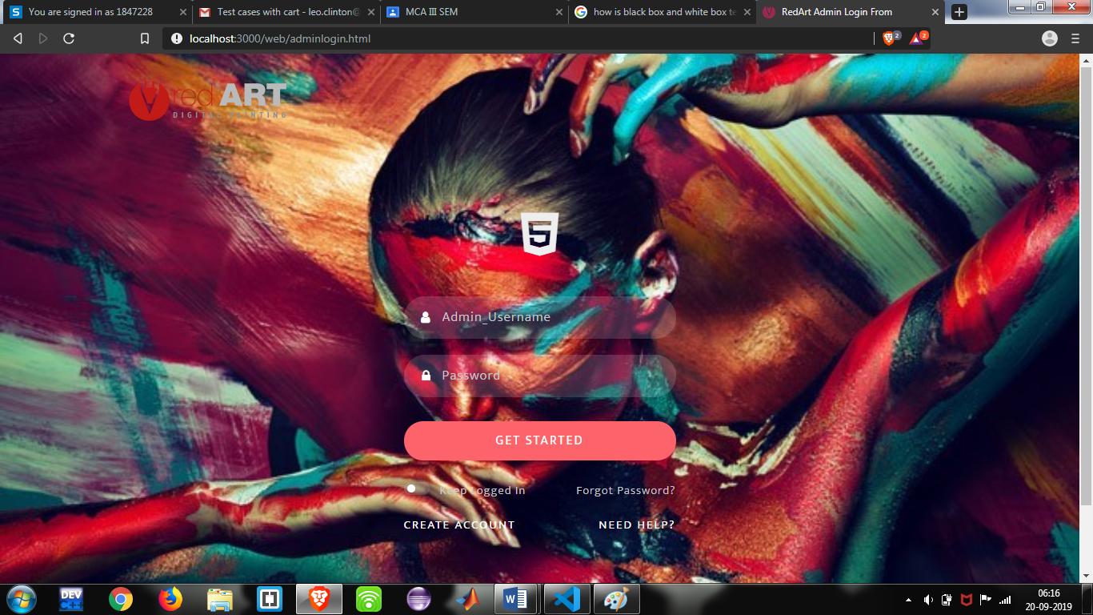

* Customer login

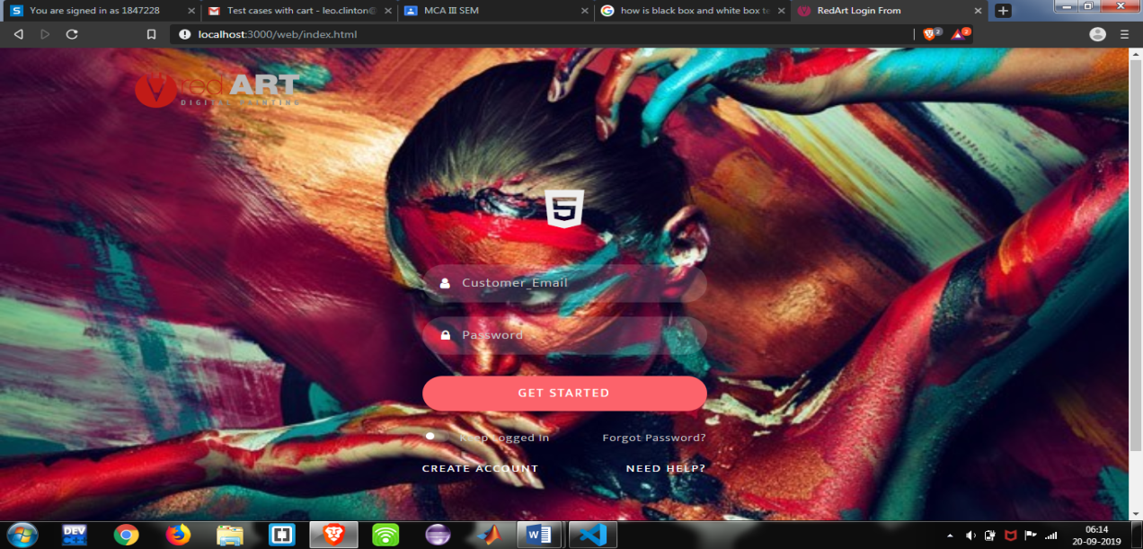

* Artist login

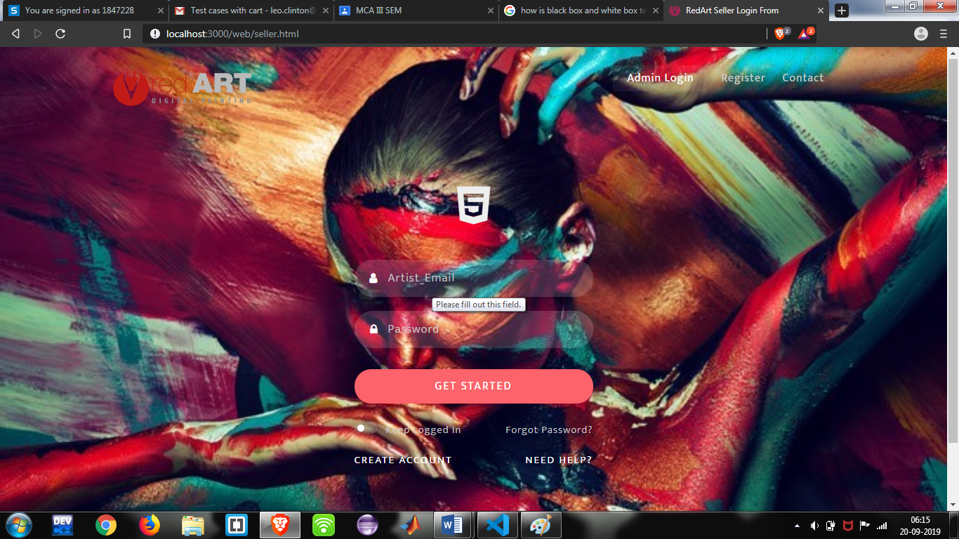

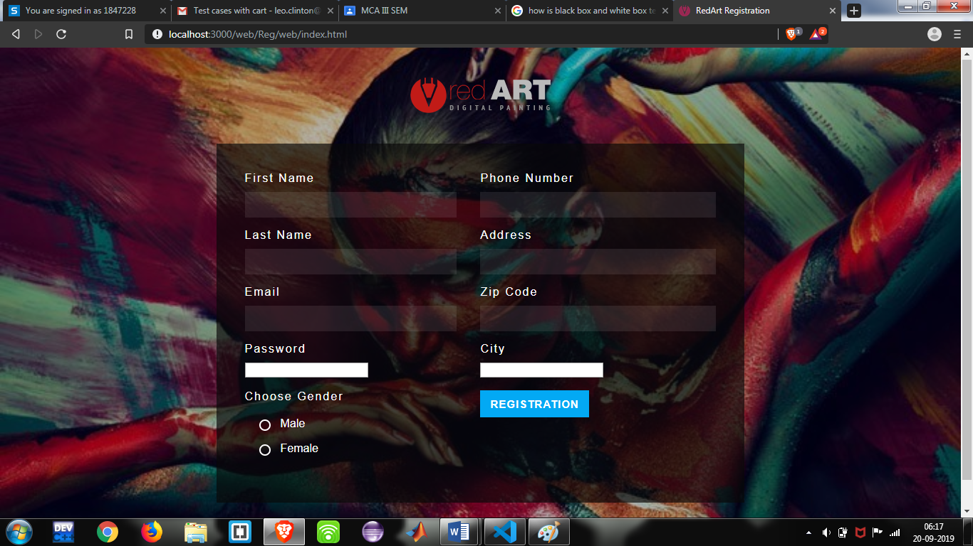

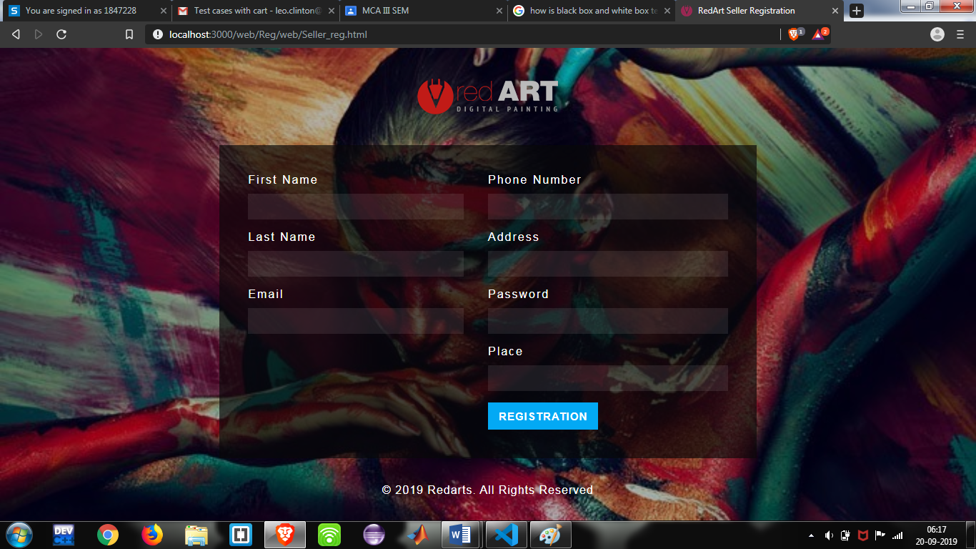

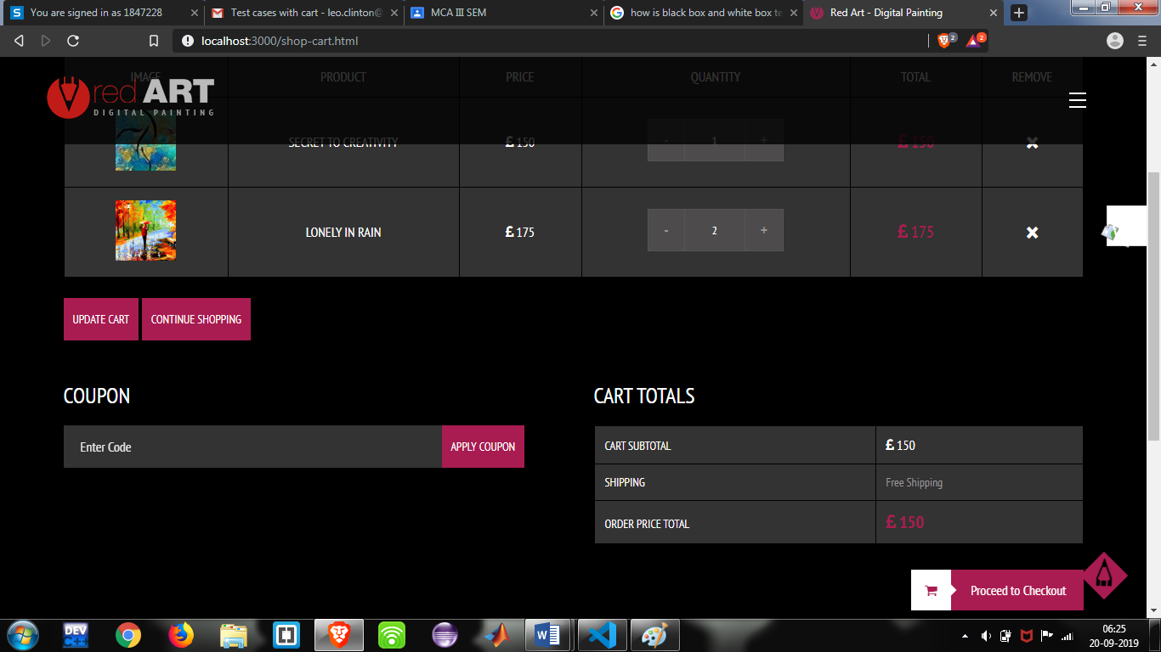

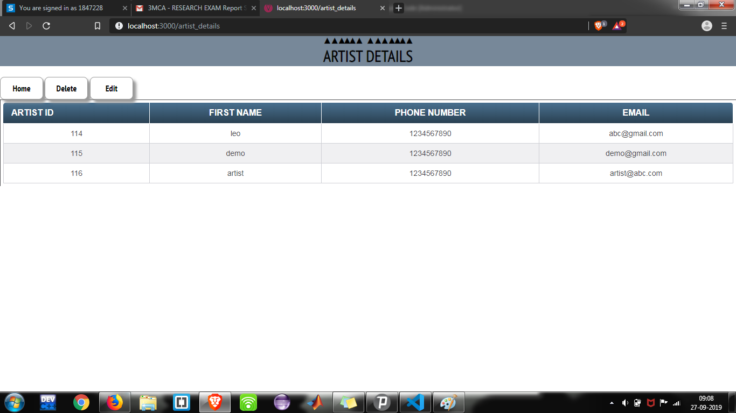

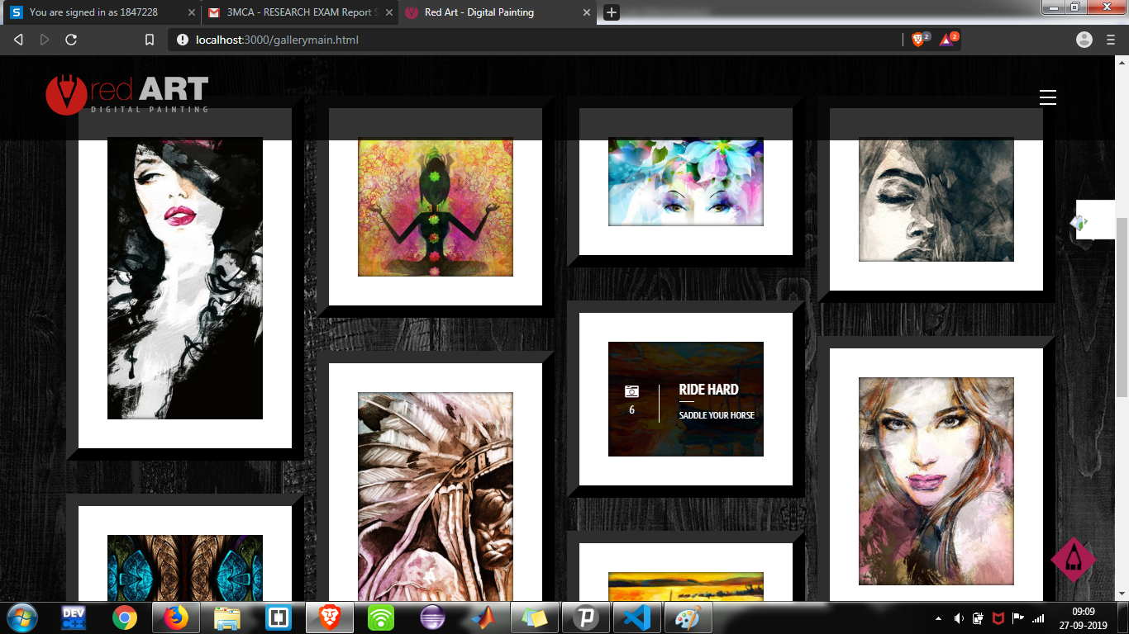

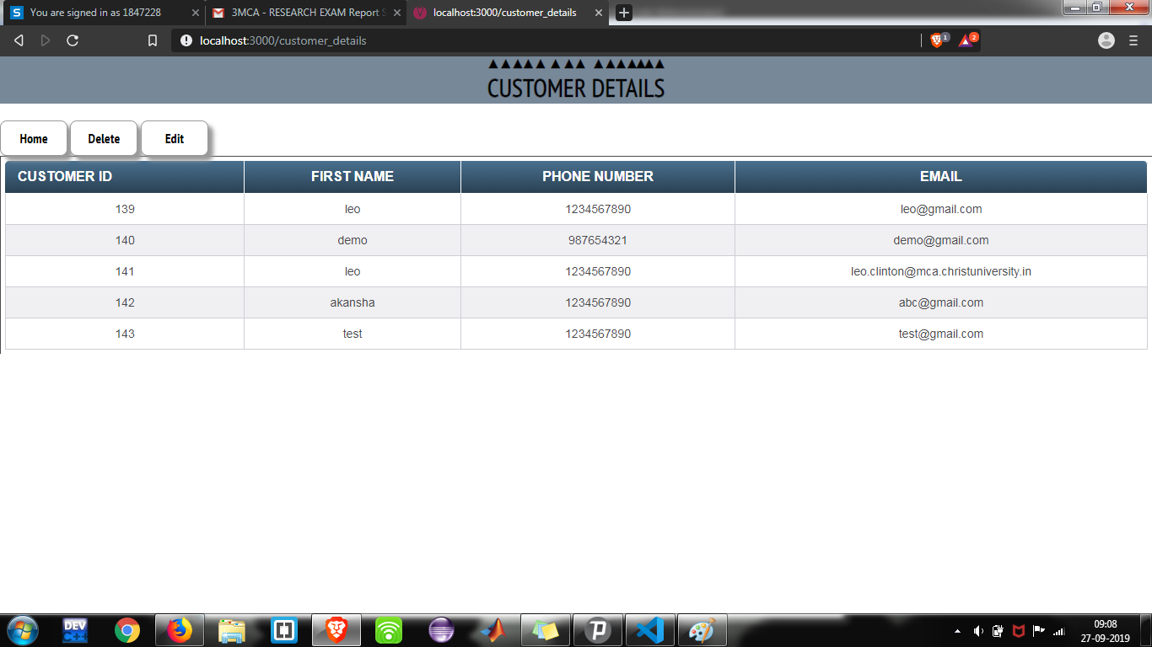

**6. TESTING**

**6.1 TEST PLAN**

Testing provides an objective, independent view of the software to allow the developers to appreciate and understand the risks of software implementation. Test techniques include, but are not limited to, the process of executing a program or an application with the intent of finding errors, bugs and defects. Software testing, depending on the testing method employed, can be implemented at any time in the development process. Traditionally most of the test efforts occurs after the requirements have been defined and the coding process has been completed.

A primary purpose of testing is to detect software failures so that defects may be discovered and corrected. Testing cannot establish that a product functions properly under all conditions but can only establish that it does not function properly under specific conditions. The scope of software testing often includes examination of code as well as execution of that code in various environments and conditions as well as examining all aspects of code: does it do what it is supposed to do and do what it needs to do. Not all software defects are caused by coding errors. One common source of expensive defects is caused by requirement gaps, e.g., unrecognized requirements that result in errors of omission by the program designer. A common source of requirements gaps in non-functional requirements such as testability, scalability, maintainability, usability, performance and security.

A very fundamental problem with software testing is that testing under all combinations of inputs and preconditions (initial state) is not feasible, even with a simple product. This means that the number of defects in a software product can be very large and defects that occur infrequently are difficult to find in testing. More significantly, non-functional dimensions of quality (how it is supposed to be versus what it is supposed to do) usability, scalability, performance, compatibility, reliability can be highly subjective; something that constitutes sufficient value to one person may be intolerable to another. We plan to test our project by various methods of testing. We aim at testing our project and run it under maximum testing combinations possible. By doing this we can check the functionality and the durability of our product. We plan to test our project in three phases, being, unit testing, integration testing and validation testing. Integration testing is the most detailed and longest process of testing as it consists of the top down approach, bottom up approach, umbrella approach, black box testing and white box testing.

**6.2 UNIT TESTING**

Unit testing is a software development process in which the smaller testable parts of an application, called units, are individually and independently scrutinized for proper operation. Unit testing is often automated but it can also be done manually. This testing mode is a component of Extreme Programming (XP), a pragmatic method of software development that takes a meticulous approach to building a product by means of continual testing and revision. Unit testing involves only those characteristics that are vital to the performance of the under under test. This encourages developers to modify the source code without immediate concerns about how such changes might affect the functioning of other units or the program as a whole.

Once all of the units in a program have been found to be working in the most efficient and error-free manner possible, larger components of the program can be evaluated by means of integrating testing. In procedural programming a unit could be an entire module but is more commonly an individual function or procedure. In object oriented programming a unit is often an entire interface, such as class, but could be an individual method. Unit testing can be time-consuming and tedious. It demands patience and thoroughness on the part of the development team. Rigorous documentation must be maintained. Unit testing must be done with an awareness that it may not be possible to test a unit for every input scenario that will occur when the program is run in a real-world environment.

**6.3 INTEGRATION TESTING**

Integration testing is the phase in software testing in which individual software modules are combined and tested as a group. It occurs after unit testing and before validation testing. Integration testing takes as its input modules that have been unit tested, groups them in larger aggregates, applies tests defined in an integration test plan to those aggregates, and delivers as its output the integrated system ready for system testing.

Top down testing is an approach to integrated testing where the top integrated modules are tested and the branch of the module is tested step by step until the end of the related module. In Top to down approach, testing takes place from top to down following the control flow of the software system. This method makes fault localization easier. There is also a possibility to obtain an early prototype. Critical Modules are tested on priority; major design flaws could be found and fixed first. The flaw with this system is that modules at lower level are tested inadequately.

Bottom up testing in an approach to integrated testing where the lowest level components are tested first, then used to facilitate the testing of higher level components. The process is repeated until the component at the top of the hierarchy is tested.

All the bottom or low-level modules, procedures or functions are integrates and then tested. After the integration testing of lower level integrated modules, the next level of modules will be formed and can be used for integration testing. This approach is helpful only when all or most of the modules of the same development level are ready. This method also helps to determine the levels of software developed and makes it easier to report testing progress in the form of a percentage. In the bottom up strategy, each module at lower levels is tested with higher modules until all modules are tested. It takes help of Drivers for testing.

Umbrella approach requires testing along functional data and control-flow paths. First, the inputs for functions are integrated in the bottom-up pattern discussed above. The outputs for each function are then integrated in the top-down manner. The primary advantage of this approach is the degree of support for early release oflimited functionality. It also helps minimize the need for stubs and drivers. The potential weakness of this approach are significant, however, in that it can be less systematic than the other two approaches, leading to the need for more regression testing.

**6.4 ACCEPTANCE TESTING**

User Acceptance Testing is often the final step before rolling out the application. Usually the end users who will be using the applications test the application before ‘accepting’ the application. This type of testing gives the end users the confidence that the application being delivered to them meets their requirements. This testing also helps nail bugs related to usability of the application.

**6.5 BLACK-BOX TESTING**

Black-box testing is a method of software testing that tests the functionality of an application as opposed to its internal structures or workings (see white-box testing). This method of test can be applied to all levels of software testing: unit, integration, system and acceptance. It typically comprises most if not all testing at higher levels, but can also dominate unit testing as well.

Black-box testing is a method of software testing that tests the functionality of an application as opposed to its internal structures or workings (see white-box testing). This method of test can be applied to all levels of software testing: unit, integration, system and acceptance. It typically comprises most if not all testing at higher levels, but can also dominate unit testing as well.

**6.6WHITE-BOX TESTING**

White-box testing (also known as clear box testing) is a method of testing softwares that tests internal structures or workings of an application, as opposed to its functionality (i.e., black-box testing). In white-box testing an internal perspective of the system, as well as programming skills, are used to design test cases. The tester chooses inputs to exercise paths through the code and determine the appropriate outputs. This is analogous to testing nodes in a circuit, e.g., in-circuit testing (ICT).

While white-box testing can be applied at the unit, integration and system levels of the software testing process, it is usually done at the unit level. It can test paths within a unit, paths between units during integration, and between subsystems during a system-level test. Though this method of test design can uncover many errors or problems, it might not detect unimplemented parts of the specification or missing requirements.

White-box testing (also known as clear box testing) is a method of testing softwares that tests internal structures or workings of an application, as opposed to its functionality (i.e., black-box testing). In white-box testing an internal perspective of the system, as well as programming skills, are used to design test cases. The tester chooses inputs to exercise paths through the code and determine the appropriate outputs. This is analogous to testing nodes in a circuit, e.g., in-circuit testing (ICT).

While white-box testing can be applied at the unit, integration and system levels of the software testing process, it is usually done at the unit level. It can test paths within a unit, paths between units during integration, and between subsystems during a system-level test. Though this method of test design can uncover many errors or problems, it might not detect unimplemented parts of the specification or missing requirements

**6.7 TEST CASES AND REPORTS**

**Test Cases**

|  |  |  |  |
| --- | --- | --- | --- |
| **Page** | **Event** | **Expected Result** | **Pass/Fail** |
| **Artist Login**  **Form** | * Incorrect Password * No Password * Incorrect Username | Login Fail  Login Fail  Login Fail | Pass |
| **Customer Login**  **Form** | * Incorrect Password * No Password * Incorrect Username | Login Fail  Login Fail  Login Fail | Pass |
| **Admin Login**  **Form** | * Incorrect Password * No Password * Incorrect Username | Login Fail  Login Fail  Login Fail | Pass |
| **Artist registration form** | * Incomplete fields * Wrong email format | Error message  Error message | Pass |
| **Customer registration form** | * Incomplete fields. * Wrong email format. | Error message  Error message | Pass |
| **Shopping Cart** | * Add one item to the cart and verify. * Increase the quantity of the item from the cart and verify. * Add the same item multiple times and verify. * Add multiple items of different types and verify. * Remove some items from the cart and verify. | Item added  Number Increased  Number not increased  Multiple item got added  Item got removed | Pass |

**7.CONCLUSION**

The website aims at solving all problems faced in the current system. The service provider and customer profiles on the website makes it easy for adding and accessing services. The website also ensures that the administrator supervises this entire process. By the means of this website, we also aim at making the process of accessing services easier and swifter for the customer. It is also an easy opportunity for the service providers to offer their services at their suitable days and time.

**7.1 ADVANTAGES**

● The proposed model will be more user friendly.

● The proposed model will be having a registration portal for both the service provider and user.

● The visibility and access to the service providers increases which can lead to more users and many more opportunities.

**7.2 LIMITATIONS**

Since, every system has some limitations so our proposed system is also not untouchable in this regard.

● It doesn’t provide different kind of access feature for different users.

● Though internet access is widespread these days, it remains true that one of the major disadvantages of online service systems are their reliance on internet connections.